1. 
2. 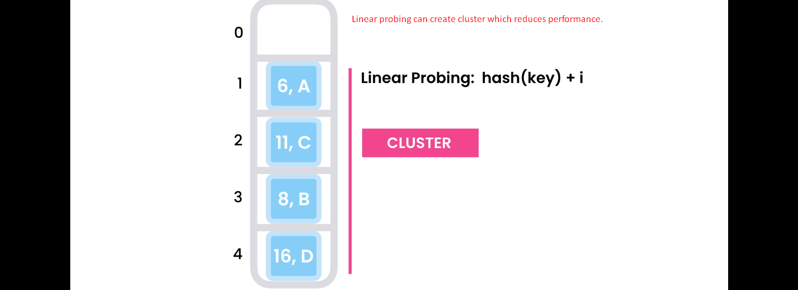
3. **Solution**: Quadratic Probing.
4. 
5. 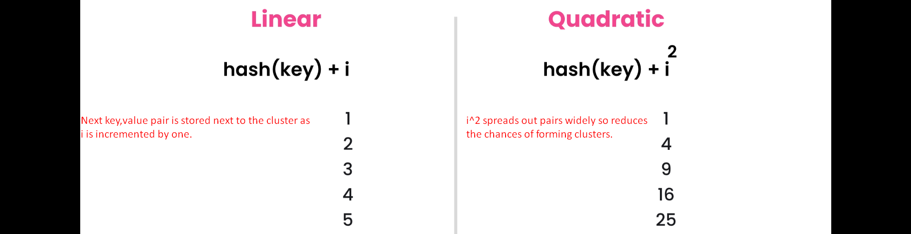
   1. Now we have quadratic equation.
6. 
7. Quadratic Probing solves the cluster problem but it creates another problem.
8. We make big jumps to find an empty slot. We can come back to the beginning of the array to the same slot and so we can end up in infinite loop.
9. 